ABE 55700

Homework 3 | Drying

Nathan LeRoy

Oct. 19th, 2018

**Problem 9.6-3**

A food material is being dried in a pan:

0.61 m

0.0254 m

0.61 m

We are told the following properties of our system:

Vair = 3.05 m/a = **10,980 m/hr**

The food material contains **11.34 kg dry solid**

The free moisture content, X1, is initially at **0.35 kg H2O/kg dry solid**

Tair = **60 °C** and the wet bulb temperature Tw = **29.4 °C**

The final free moisture content X2 = **0.22 kg H2O/kg dry solid**

We are also told that the drying rate was found to be in the constant rate period.

We can estimate the constant drying rate with the following formula:

$$R_{c}=\frac{h}{λ_{w}}\left(T_{air}-T_{w}\right)\left(3600\right)$$

where $λ_{w}$ is the latent heat of vaporization of water (2,260 kJ/kg), and *h* is the convective heat transfer coefficient. In addition, we can then subsequently estimate the time of drying by the following equation:

$$t=\frac{L_{s}}{AR_{c}}\left(X_{1}-X_{2}\right)$$

The convective heat transfer coefficient, *h*, can be estimated with the following equation:

$$h=0.0204G^{0.8}, where G is the gas mass velocity$$

$$h=0.0204{\left(\left(10,980m/hr\right)\left(1.06 kg/m^{3}\right)\right)}^{0.8}=36.51W/m^{2}K$$

Thus,

$$R_{c}=\frac{36.51}{2.260e6}\left(60°C-29.4°C\right)\left(3600\right)=1.78 kg H_{2}O/h-m^{2}$$

Thus, the time required to dry is,

$$t =\frac{11.34kgdry}{{0.61}^{2}m^{2}\left(1.78\frac{kgH_{2}O}{h-m^{2}}\right)}\left(0.35\frac{kgH_{2}O}{kgdry}-0.22\frac{kgH_{2}O}{kgdry}\right) = 2.23 hrs$$

In the constant rate drying regime, we can assume that the thickness is linearly proportional to the drying time:

$$\frac{t_{1}}{L_{1}}=\frac{t_{2}}{L_{2}} or \frac{L_{2}t_{1}}{L_{1}}=t_{2}$$

Thus,

$$t_{2}=\frac{44.5mm}{25.4mm}\left(2.23hr\right)=3.90hrs$$

**Problem 9.9-3**

We are given data on the relative moisture content over time. Specifically, the ratio of the current moisture content to the critical moisture content, $\frac{X}{X_{c}}$. The data is given in the following table:

|  |  |
| --- | --- |
| **X/Xc** | **t (hours)** |
| 1.0 | 0 |
| 0.65 | 0.25 |
| 0.32 | 7.0 |
| 0.17 | 11.4 |
| 0.10 | 14.0 |
| 0.06 | 16.0 |

We know that the data follow the diffusion equation:

$$t=\frac{4x_{1}^{2}}{π^{2}D_{L}}ln\left(\frac{8X_{c}}{π^{2}X}\right)$$

where $x_{1}$ is the half thickness, $D_{L}$ is the diffusion coefficient, $X_{c}$ is the critical moisture content, and X is the current moisture content at time t. We can plot the natural logarithm of $\frac{8X_{c}}{π^{2}X}$ against the time and the slope will then be equal to $\frac{4x_{1}^{2}}{π^{2}D_{L}}$. Using the known thickness and other constants we can then get a value for the diffusion coefficient.

The slope was found to be 0.0697 hr-1. Thus, we can predict the diffusion coefficient to be equal to:

$$\frac{\left(0.0697\right)4x_{1}^{2}}{π^{2}} = 1.311e-6$$

**Problem 9.7-2**

We are given data on the weight of a material over time:

|  |  |
| --- | --- |
| **Time (hr)** | **Weight (kg)** |
| 0 | 4.944 |
| 0.4 | 4.885 |
| 0.8 | 4.808 |
| 1.4 | 4.699 |
| 2.2 | 4.554 |
| 3.0 | 4.404 |
| 4.2 | 4.241 |
| 5.0 | 4.150 |
| 7.0 | 4.019 |
| 9.1 | 3.978 |
| 12.0 | 3.955 |

We also know that the dry sample weight is 3.765 kg, while the equilibrium weight of our product is 3.955. This lets us calculate the equilibrium moisture content or bound water content, **0.190 kg.** Thus we can calculate the total free moisture in our sample at the beginning:

$$X_{free,o}=\frac{4.944kg-3.765kg-0.190kg}{3.765 kg dry solid}=0.263 kg{ H}_{2}O$$

This process is repeated for each time point to get the moisture content. We can then estimate the rate of drying between each point with the following equation:

$$R=-\frac{L_{s}}{A}\frac{∆X}{∆t}$$

We can then use a numerical integration technique to estimate the time to dry product between two moisture content levels. These calculations were done in excel and the sheet with the final time is attached. The final calculated to be:

4.63 hrs

**Problem 9.8-1**

This problem is similar to problem 9.6-3, however we need to consider that radiation is being applied to the surface of our material as well. Thus, this time around, the total energy transfer to our product can be written as:

$$q_{tot}=q_{c}+q_{r}$$

Where,

$$q_{c}=h_{c}\left(T-T_{s}\right)A,andq_{r}=h_{r}\left(T-T_{s}\right)A$$

One can estimate the radiation coefficient by the following equation,

$$ϵ\left(5.676\right)\frac{{\left(\frac{T_{R}}{100}\right)}^{4}-{\left(\frac{T_{s}}{100}\right)}_{}^{4}}{T_{R}-T_{s}}$$

Thus, we can now create the following relation:

$$R_{c}=\frac{q}{Aλ_{s}}=\frac{h_{c}\left(T-T_{s}\right)+h_{R}\left(T_{R}-T_{s}\right\}}{λ_{s}} =k_{y}M_{B}\left(H_{s}-H\right)$$

Rearranging and substituting in the specific heat capacity, we achieve an equation which related the temperature of the surface, the air, and the radiation temperature to the coefficients of heat transfer for convection and for conduction with the air humidity and saturation humidity:

$$\frac{\left(H_{s}-H\right)λ_{s}}{c_{s}}=\left(T-T_{s}\right)+\frac{h_{R}}{h_{c}}\left(T_{R}-T_{s}\right)$$

We know that hR is a function of Ts and thus we can use a solving algorithm (excel) to solve for the surface temperature of our material. This was done in excel (See attached calculations)

Ts was found to be: $30.32°C$

The drying rate can now be estimated using the following equation:

$$R_{c}=\frac{h}{λ_{w}}\left(T_{air}-T_{s}\right)\left(3600\right)$$

$$R_{c}=\frac{35.84}{2424e6}\left(338.6-303.32\right)\left(3600\right)$$

$$R_{c}=1.88\frac{kgH_{2}O}{h-m^{2}}$$

(See attached excel document for calculation set up)

**Problem 9.10-5**

The system is described as such:

Air out

Air in

Dryer

Product Out

Product In

The material comes in wet and is to be dried to specific specifications. We are given specifications about the air coming in and out of our system and must calculate the time that the material must spend in the dryer. The exact specifications are already given in the attached excel sheet, and there is *no* reason to repeat them in this document.

We know that the drying rate is equal to:

$$R=k_{y}M_{B}\left(H_{w}-H\right)=\frac{h}{λ_{w}}\left(T_{air}-T_{w}\right)$$

And, we also know that the time required for drying of the material can be calculated using the following equation from Geankopolis:

$$t=\frac{G}{L_{s}}\left(\frac{L_{s}}{A}\right)\frac{1}{k_{y}M_{B}}ln\left(\frac{H_{w}-H_{c}}{H_{w}-H_{1}}\right)$$

The equation can be modified to include the log-mean humidity difference,

$$t=\frac{G}{L_{s}}\left(\frac{L_{s}}{A}\right)\frac{1}{k_{y}M_{B}}ln\left(\frac{H_{1}-H_{c}}{∆H_{lm}}\right)$$

Where,

$∆H_{lm}$ = $\frac{H_{1}-H_{c}}{ln\left(\frac{H_{w}-H_{c}}{H_{w}-H_{1}}\right)}$ and $H_{c}=H_{2}+\frac{L_{s}}{G}\left(X_{c}-X_{2}\right)$

However, the first humidity is not given. But, we can obtain it from a simple mass balance

$$GH_{2}+L_{s}X_{1}=GH_{1}+L_{s}H_{2}$$

The exact calculations were all done in an excel sheet, which is attached. The exact drying time was found to be 4.22 hrs.

**Problem 9.10-6**

The system was described as the following:

T = 25.6 C

H = 0.01 kg H2O/kg Dry Air

G = ?

T = 26.7

H = 50 % H2O w/w

m = ?

T = 26.7

H = 27 % H2O w/w

m = 702.2*(1-0.27) kg DS/hr

Product Stream 2

Product Stream 1

Air Stream 2

Air Stream 1

Dryer

Heater

T = 25.6 C

H = 0.007 kg H2O/kg Dry Air

m1 = ?

Air Stream 4

T = 37.8 C

H = 0.02 kg H2O/kg Dry Air

G = ?

Air Stream 3

T = 65.6 C

H = 0.01

m = G

T = 37.8 C

H = 0.02 kg H2O/kg Dry Air

m2 = ?

Air Stream 5

First, we need to find the mass flow rate of air through the system:

$$G=\frac{L_{s}\left(X_{2}-X_{1}\right)}{\left(H_{2}-H_{1}\right)}$$

(In excel) G was found to be, **32,301.2 kg dry air/hr**

To get the mass flow rates of the other streams we must perform a mass balance around the water and air in our system. We know that the total dry air flowing into our heater is equal to the total dry air flowing our of the heater, which was calculated to be 32,301.2 kg/hr.

In addition, the water coming into the heater is equal to the amount of water coming out of our heater. Mathematically, this can be written as such:

$$m_{1}+m_{2}=32,301.2kgdryair/hr$$

$$m_{1}\left(0.007\right)+m_{2}\left(0.02\right)=32,301.2\left(0.01\right)$$

This is a system of two equations with two unknowns which is in fact solvable. $m_{1}$ was found to be 24,847.1 kg dry air per hour, while $m_{2}$ was found to be 7454.17.12 kg dry air per hour. These are the fresh air and recycled air streams respectively. We can then calculate the percent of air recycled:

$$\%Recycled=\frac{m_{2}}{m_{1}+m_{2}}$$

This number was found to be 23.02%

**Freeze Drying Derivation**

Freeze drying with only conduction against the wall:

We know that the heat transfer through the ice material is equal to the heat transfer through the dried material which is equal to the heat of sublimation:

$$q_{dry}=q_{ice}=∆H_{sub}N_{A}$$

$$\frac{k_{d}}{L-∆L}\left(T_{s}-T_{f}\right)=\frac{k_{i}}{∆L}\left(T_{w}-T_{f}\right) =∆H_{sub}N_{A}$$

Knowing that $∆L=\left(1-X\right)L$ and that $N_{A}=\frac{-dx}{dt}$

We can simplify our equation to become:

$$\left(T_{w}-T_{s}\right)\left(\frac{M_{A}V_{s}}{L∆H_{s}}\right)dt=\frac{1}{k_{d}k_{i}}\left(k_{i}LX+\left(1-X\right)Lk_{d}\right)dx$$

We can integrate and then get an equation for the drying time

**Appendix/Excel Sheets**

Problem 9.9-3:

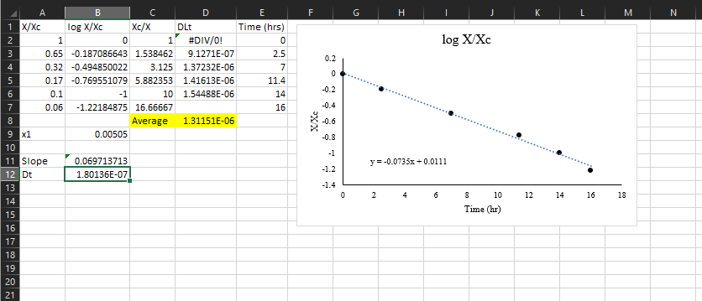

Problem 9.7-2:

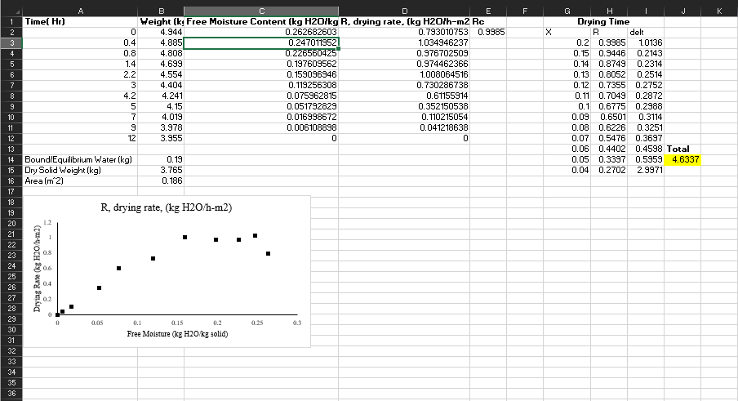

Problem 9.8-1:

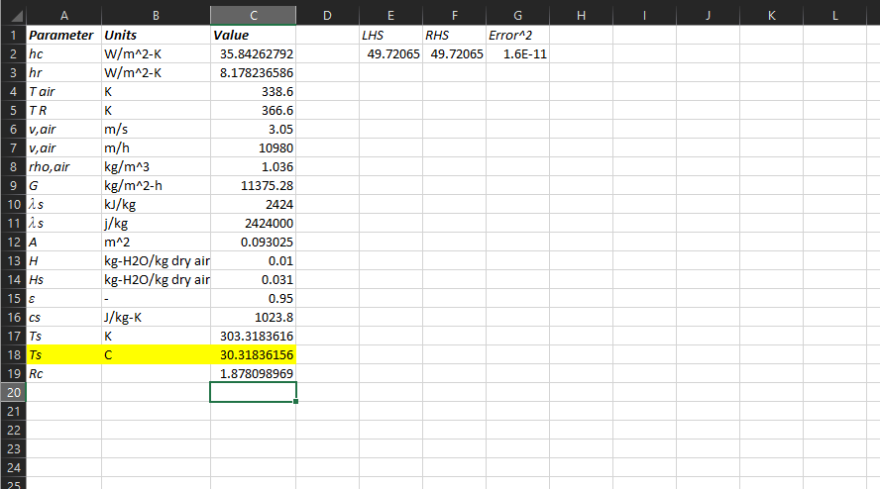

Problem 9.10-5:

